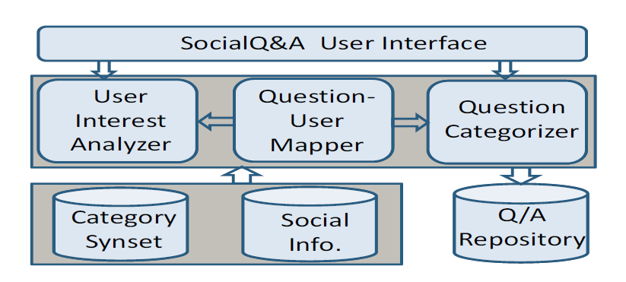

**Category Synsets**

Which stores the synonyms of all categories’ keywords. According paper we take 4 main categories, those are **music, movies, television, and books.**  Collecting keywords from wordnet and manually. This data will helps to User Interest Analyzer and Question Categorizer.

**User Interest Analyzer**

User Interest Analyzer collects each user profile from database and user question and answer interactions. System will count the WI weight of Interest of category’s based on question and answer interactions.

*Example*

|  |  |  |  |  |
| --- | --- | --- | --- | --- |
| **User** | **Music** | **Movies** | **Television** | **Books** |
| Sajid | 3 | 1 | 0 | 0 |
| Swamy | 2 | 1 | 1 | 0 |

**Question Categorizer**

Question Categorizer is a process of find the category of a question, based on topic words of a question and compare with category synset.

*For Example:*

***Q:*** *Please anybody suggest me the book for multimedia systems?*

***Category****: Books*

**Question-User Mapper**

* **Weight Calculation**

ψI, Uk =

* + Summation of asker’s friend weight of interest of a category. [Algorithm 1]
* **Interest similarity**

P**S**=

* + Where **S** is Interest similarity between asker and his/her friends.
  + PS =
* **Asking and answering interaction**

P**A**=

* + Where **A** is asking and answering interaction count between asker and his/her friends.
  + PS =
* **Common Friends Count**

P**C**=

* + Where **C** is common friends count between asker and his/her friends.
  + Pc =

**The social closeness of friend Uk is calculated as**

|  |
| --- |
| ΨC, Uk ­­­= ɣS* P**S +** ɣA* P**A +**  ɣP* P**c** ;  Where ɣS, ɣA ,ɣP are the weights of considering factors S, A and C, respectively. [take 0.5] |

**Calculate the metric ΨUk**

|  |
| --- |
| ΨUk ­­­= ᵦ * ψI, Uk**+** (1-ᵦ)* ΨC, Uk ; (0 < ᵦ < 1); |

**System Security:**

**The friendship through online social networks may not be always trustable. So here we need to secure the user’s friendship information and** interests**. We used hashing technique using for secure the data.**